Using the Manning Word template
Updated 11/1/07
This document describes how to make sure your book’s styles match the Word template styles, which will in turn match the typesetter’s Frame styles—thus making everyone’s job as easy as possible. The Manning Word template is protected, to ensure that no one can accidentally change the styles or add new styles to the template. If you absolutely need to add or change a style for some reason, please talk to your Development Editor, who will contact the Production Editor and typesetter to determine the best solution.
The Manning style sampler
Before you begin writing, please review the document Manning style sampler. This document describes how, where, and when to use all the styles included in the Word template. It’s your best and most comprehensive source of information for how to apply text styles; insert tables, code listings, and figures; work with code annotations; add callouts and sidebars; and much more.
To begin writing
When you’re ready to write, do one of the following:
- Install the Manning template in the Templates folder on your computer. When you’re ready to start a new document, choose File > New, locate the template, and open it.
or
- Start with this document or the Manning style sampler document. Press Ctrl+A to select all the text, and then press Delete. Choose File > Save As, save the document under a new name, and you’re ready to go.
If you’ve done some writing in a different template…
If you’ve already started writing using another template, you need to import the text into the protected Word template and apply the correct styles. Here’s how:
- Open a new document using the Manning template, as described in the previous section.
- Choose Insert > File, locate and select your existing document, and click Insert.
- Word inserts the chapter into the template. Any text that is not formatted with a Manning style is imported with the Normal style.
- Look through the document and apply the appropriate styles as necessary.
Note
Always, always begin in the Manning template, whether you’re writing from scratch or importing existing text. Do not open another document and attach the Manning template to it. Doing so defeats the purpose of protecting the Manning styles and allows unwanted changes to be made.
Page counts, indexes, and TOCs
The Manning toolbar includes three buttons designed to help you keep track of how much you’ve written, add index entries and determine how many index entries you’ve entered, and examine how your chapter is organized (see figure 1).
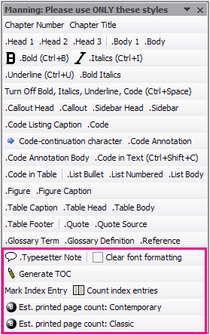
Figure 1 The Manning toolbar. If it isn't visible in your document, choose View > Toolbars > Manning.
Estimating your printed page count
To estimate how many printed pages will result from the current Word chapter, click the Estimate Printed Page Count: Contemporary or Estimate Printed Page Count: Classic button on the Manning toolbar, depending on which design your book is using. (Your development editor can tell you, if you don’t know.) A dialog box appears that gives the estimated number, as shown in figure 2.
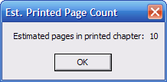
Figure 2 Clicking the Estimate Printed Page Count button displays a dialog box that tells you how your Word pages will correlate to typeset pages.
Note that this is only an estimate. Any given chapter’s count may be exact, or it may be off by 10%. However, over the course of an entire book, the estimate will be usefully accurate.
Adding index entries
Because the Manning template is protected, you can’t add index entries the usual way (by choosing Insert > Reference > Index and Tables, and so on). Instead, click the Mark Index Entry button on the Manning toolbar to open the Mark Index Entry dialog box. From there, you can proceed as outline in the document Indexing guidelines.
Counting index entries
Your readers want and need an index that is comprehensive. To ensure a useful index, the number of indexed terms should total at least 2% of your word count.
To count the index entries you’ve entered in a chapter, click the Count Index Entries button on the Manning toolbar. The resulting dialog box (shown in figure 3) tells you how many words are in the chapter, the minimum number of index entries the chapter should have ideally, how many index entries the chapter currently has, and how many (if any) you need to add.
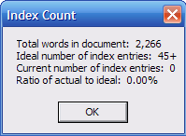
Figure 3 Clicking Count Index Entries tells you how many more index entries you need to enter (at minimum) to ensure a useful index for your book.
Please do your utmost to reach the minimum number of entries. If possible, 3%–4% will make your index even more useful to your readers. 3For more information on how to prepare an index, please refer to the 10 - Indexing Guidelines document on Gregor in Author Resources > Template and Writing Resources.
Generating a table of contents
It’s easy to lose track of heading numbers in a long chapter. And it helps to be able to review a table of contents to recall how you’ve organized your text.
To insert a table of contents for the chapter, click the Generate TOC button on the Manning toolbar. For instance, clicking the button for this document generates the following result:
The Manning style sampler 1
To begin writing 1
If you’ve done some writing in a different template… 1
Page counts, indexes, and TOCs 2
Estimating your printed page count 2
Adding index entries 3
Counting index entries 3
Generating a table of contents 3

